[Integrate D365 FO & SCM with cloud applications and on-premise shop floor systems using Unified Name Space (UNC) concept and MQTT technology]

Applies to: Dynamics 365 Finance, Dynamics 365 Human Resources, Dynamics 365 Supply Chain Management, Unified Name Space ( UNS) and MQTT.
A Unified Namespace (UNS) in the context of Dynamics 365 (D365) creates a centralized, real-time data hub (often using MQTT) that bridges Operational Technology (OT) and Information Technology (IT), allowing D365 to act as a single source of truth for business data. It eliminates data silos by organizing industrial data (via ISA-95) from factory floors, integrating it directly into Dynamics 365 Finance, Supply Chain, and Field Service.
Customer is a pioneer and key enabler for the recycling industry using multiple OT systems (PLC, SCADA etc) . The solution for the customer combines D365 Finance, D365 SCM, Unified Name space MQTT technology to integrate various on-premise shop floor systems ( MES, SCADA) with cloud business systems ( D365 ERP).

Introduction
This Project is an deployment of D365 Finance , D365 SCM and D365 Manufacturing along with various other satellite systems. This solution caters to provide Integrations using UNS as the middleware as organization has various shop floor systems. There were 10+ different 3rd party applications in cloud which need to be integrated with 10+ shop floor systems on-premise.
We used UNS MQTT as middleware for transformation and to seamlessly transfer the data from cloud and on-premises. The key need of this solution was to develop a custom Integration solution to cater to seamless connectivity between D365 FO to On-premises shop floor applications.

Architecture
The following diagram illustrates the architecture for the solution.
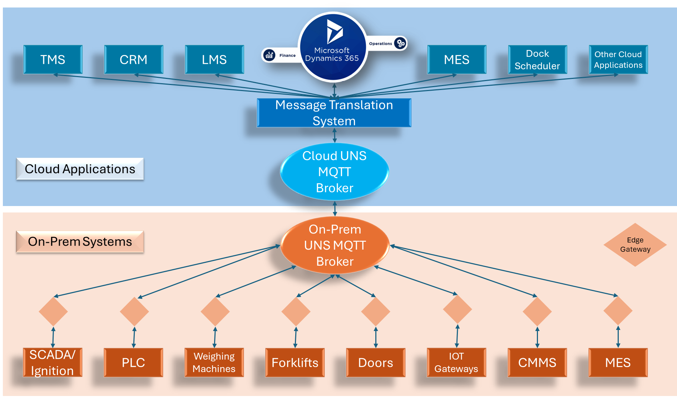

Download a PowerPoint file with this architecture.

Dataflow

The Unified Namespace (UNS) approach transforms industrial architecture by replacing rigid, point-to-point connections with a centralized, event-driven broker. Instead of systems like SCADA and Data Historians requiring individual, vendor-specific APIs for every connection, the UNS acts as a single source of truth where data is published once and accessed by many. This publish-subscribe model, often utilizing MQTT, allows an edge node to transmit data to a central broker just once, which then automatically distributes it to any number of subscribed applications. By decoupling the data source from the consumer, this architecture significantly reduces integration complexity, promotes centralized data governance, and offers a highly scalable alternative to traditional, difficult-to-maintain industrial integration methods.

Accounts receivable Process:
- Customer master is created in cloud based CRM application and flows to D365 FO leveraging the near real time OData Restful service through middleware UNS MQTT
- Product/Item master is created in D365 FO and is exposed to other applications like LIMS, SPS, FCS using OData Restful Service through middleware UNS MQTT
- Sales orders are created in D365 FO and details are transferred to external Transportation Management system and Dock Management system using OData through middleware UNS MQTT
- Sales orders are processed and invoiced in D365 FO.
- Customer Payments are made on D365 FO
Accounts Payable Process:
- Vendor master is created in another master data application and sent to D365 FO through UNS MQTT middleware and OData.
- Purchase Orders are created, and while receiving the product, the weight details are sent from weighing machine to D365 through on-premise MQTT broker to cloud MQTT broker.
- Before receipt of item purchase order date details are passed to external TMS application using MQTT broker middleware and also to Dock Management software.
- Quality inspection values of receipt items are passed to LIMS application through MQTT middleware and OData technology.
- Vendor Invoices were booked and payments were performed in D365 FO
Planning and Production:
- While running the master planning D365, need input from two external custom made systems. Data from these systems are transferred through middle ware MQTT using OData restful API. Data from planning is also sent back to these systems using the same route.
- During production, inputs from PLCs and SCADA were captured by on premise MQTT broker and sent to D365 through cloud MQTT broker and OData services.
- The quality inspection post completion of production also involves middleware and OData to connect with LIMS systems.

Components
The following components were used in reference architecture.
- Cloud UNS MQTT broker: Acts as middle ware for all cloud-based applications
- On Premise UNS MQTT broker: Acts as middle ware for all on-premises based applications
- OData: Used to connect application and middleware
- Cloud based applications: These are applications like D365 ERP, LIMS, TMS that reside in cloud
- On Premise based hardware: These are hardware like SCADA, Weighing Machines that reside in shop floor.

Scenario details
The customer is involved in heavy automated production lines having IoT, SCADA and other shop floor systems. They decided to implement D365 Finance, D365 Supply chain Management along with D365 Manufacturing and MES systems. There are various satellite systems like third party CRM, and customer specific custom applications. In addition, SCADA, IoT, Docks etc to be integrated into cloud applications. After various discussions it was decided to leverage Unified Name Space concept using MQTT 4.0 technology which acted as middle ware. All satellite applications connected to middleware using OData technology. The deployment involved Finance, Purchase, Sales, Quality, Planning , Warehouse and Production modules.

Potential use cases
This solution was created for connecting cloud applications and on premises IIOT systems like SCADA, PLC , MES etc. It provides a seamless pub-sub model for future proof integrations. It is applicable for manufacturing industries and other industries where IIoT devises are used. It can be used by any organization which uses ERP applications catering to heavy seamless integrations built around.

Considerations
These considerations help implement a solution that includes Dynamics 365. Learn more at Dynamics 365 guidance documentation.

Cost optimization
Cost optimization is about looking at ways to reduce unnecessary expenses and improve operational efficiencies. For more information, see Overview of the cost optimization pillar.
Unified Namespace (UNS) license costs vary widely based on vendor and scale, often ranging from a few thousand dollars for smaller setups to over $35,000+ for enterprise-grade, unlimited, or perpetual licenses. Popular solutions like Inductive Automation’s Ignition start around $3,280 for base modules, with Pro ($24,370) and Ultimate ($34,990) packages offering broader capabilities.
Key Pricing Factors and Examples:
- Inductive Automation (Ignition): Offers a modular approach. Core functionality starts around $3,280, while full packages for SCADA, IIoT, and MES range from $15,925 to $34,990 for full, unlimited, or perpetual licensing.
- Alternative Solutions: Other industrial IoT platforms or middleware solutions may use subscription-based pricing, with some enterprise-level tools ranging from $5,000 to $10,000+ per year.
- License Types: Options typically include perpetual licenses (pay once, with optional support renewals) or annual subscriptions.
- Key Components: Costs often include MQTT brokers, protocol converters (OPC-UA), and data management tools
For small-scale or testing, many providers offer free or low-cost ($9/mo) entry points. For large-scale production, costs are determined by throughput and reliability requirements

//Deploying [name of solution]

// Implementing [name of solution]

//Procedure: [Name of procedure]

//Next step

//Related patterns

Related resources
Review the following related architecture guides, solutions, and other guidance content:
- https://learn.microsoft.com/en-us/azure/iot/iot-mqtt-connect-to-iot-hub
- https://learn.microsoft.com/en-us/azure/event-grid/mqtt-support Tags
Industries: Manufacturing (20-39)
Stakeholders: Accounts payable, Accounts receivable Engineering, Finance, Human Resources, IT, Operations, Production, Purchasing, Transportation, Manufacturing Execution System and Planning
Products: Dynamics 365 Finance, Dynamics 365 Human Resources, Dynamics 365 Supply Chain Management, Unified Name Space, MQTT.

Contributors
This article is maintained by Microsoft. It was originally written by the following contributors.
Other contributors:
https://www.linkedin.com/in/raffe-m-s-8967a7291

